Lecture No. 12 PARASITOLOGY DR.Raad H.H.
Phylum Acanthocephala
The Acanthocephala (Greek ακανθος, akanthos, thorn + κεφαλη, kephale, head) is a phylum of parasitic worms known as acanthocephales, thorny-headed worms, or spiny-headed worms, characterized by the presence of an protrusible proboscis, armed with with a set of specific hooks spines, which it uses to pierce and hold the gut wall of its host. Acanthocephalans typically have complex life cycles, involving (infecting) a number of hosts, including invertebrates, fishes, amphibians, birds, human and mammals. About 1150 species have been described.
Acanthocephalans are highly adapted to a parasitic mode of life, and have lost many organs and structures through evolutionary processes. intestinal parasites that take up nutrition parenterally.
Acanthocephalans lack a mouth or alimentary canal. This is a feature they share with the cestoda (tapeworms), although the two groups are not closely related. Adult stages live in the intestines of their host and uptake nutrients which have been digested by the host, directly, through their body surface.
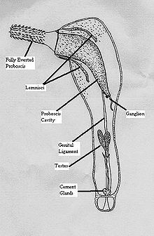

The size of the animals varies greatly, from forms a few millimetres in length to Gigantorhynchus gigas, which measures from 10 to 65 centimetres (3.9 to 26 in).
The Acanthocephala are dioecious; Vertebrates are used as final (definitive) hosts, arthropods as intermediate hosts; Females of all acanthocephalans release fully embryonated eggs ;The L1, the Acanthor. After being taken up by the 2nd. intermediate host the acanthor changes its morphology and becomes an Acanthella ,which it is encysted in stage is called a Cystacanth which is the infective stage to the final (or paratenic) host.
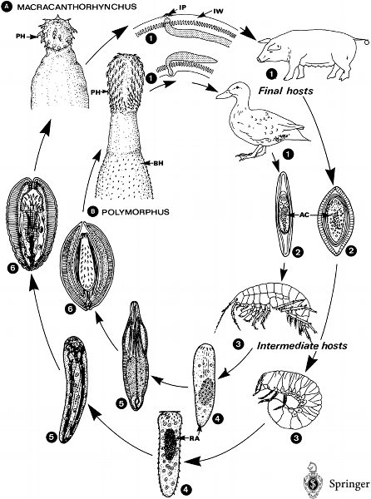

Fig. Life cycle of common acanthocephalan species . Macracanthorhynchus hirudinaceus; B . 1 The adults live in the intestine of their final hosts, being attached by their hooked proboscis. The penetration of the intestinal wall leads to inflamed protrusions (IP) appearing along the outer side. 2 After copulation the adult females excrete eggs for several months (patent period). These eggs are passed fully embryonated (i.e. they contain the hooked larva) with the feces of the host. 3-6 Intermediate hosts ( Gammarus spp. or beetle larvae) become infected by ingesting infective eggs. Inside the intestine the acanthor is released from the egg (4; RA), enters the body cavity and is transformed into an larva (5). The latter matures within 60-95 days (in M. hirudinaceus) and is described as an infective larva (). Infection of the final hosts occurs when they swallow infected intermediate hosts. The young worms reach sexual maturity within 60-90 days in M. hirudinaceus (after 20 days in Polymorphus minutus) and start egg production (= end of prepatent period). AC, acanthor; BH, body hooks; IP, inflamed protrusion of IW; IW, intestinal wall; PH, proboscis hooks; RA, released acanthor

Oncicola canis
found in the intestine of dogs, coyotes, cats, lynx and bobcats. Chance infections can occur in young turkeys and cause cysts in the esophageal wall.

Polymorphus boschadis found in the posterior part of the small intestine of many domesticated and wild birds including ducks and fowls. Causes anemia, wasting and enteritis, and heavy infestations cause death losses in colonies of aquatic birds.
Moniliformis moniliformis that can infect humans.

